SELF LEARNING REPORT-1
Agile, DevOps, and Project Management Tools
A practical overview of Agile vs. DevOps, Jira vs. Asana, and how User Stories connect to Acceptance Criteria

Introduction
Modern software development teams work across two closely connected areas: how software is planned and developed through Agile methodologies, and how it is delivered, deployed, and maintained through DevOps practices and culture. Both areas are supported by disciplined requirements engineering, which ensures that stakeholder needs are properly understood, clearly documented, and verified before a feature is considered complete.
This report explores four interconnected topics that collectively explain the journey from identifying a stakeholder requirement to developing, verifying, and delivering a software feature. It begins with the fundamental concepts of DevOps and its relationship with Agile methodology, followed by a practical comparison of two commonly used collaboration and project management platforms, Jira and Asana, illustrated with a real-world case study. The report then turns to requirements engineering itself, covering the creation of user stories and acceptance criteria, and closes with requirement tracking using a Requirements Traceability Matrix (RTM).

Agile vs. DevOps
DevOps is best understood, per Amazon Web Services, as the combination of cultural philosophies, practices, and tools that increase an organization's ability to deliver applications and services at high velocity — evolving and improving products faster than traditional development and infrastructure approaches allow. Under a DevOps model, development and operations are no longer siloed; teams often merge so engineers work across the full lifecycle, from development and testing through deployment and operations (when security is folded in too, this is called DevSecOps).
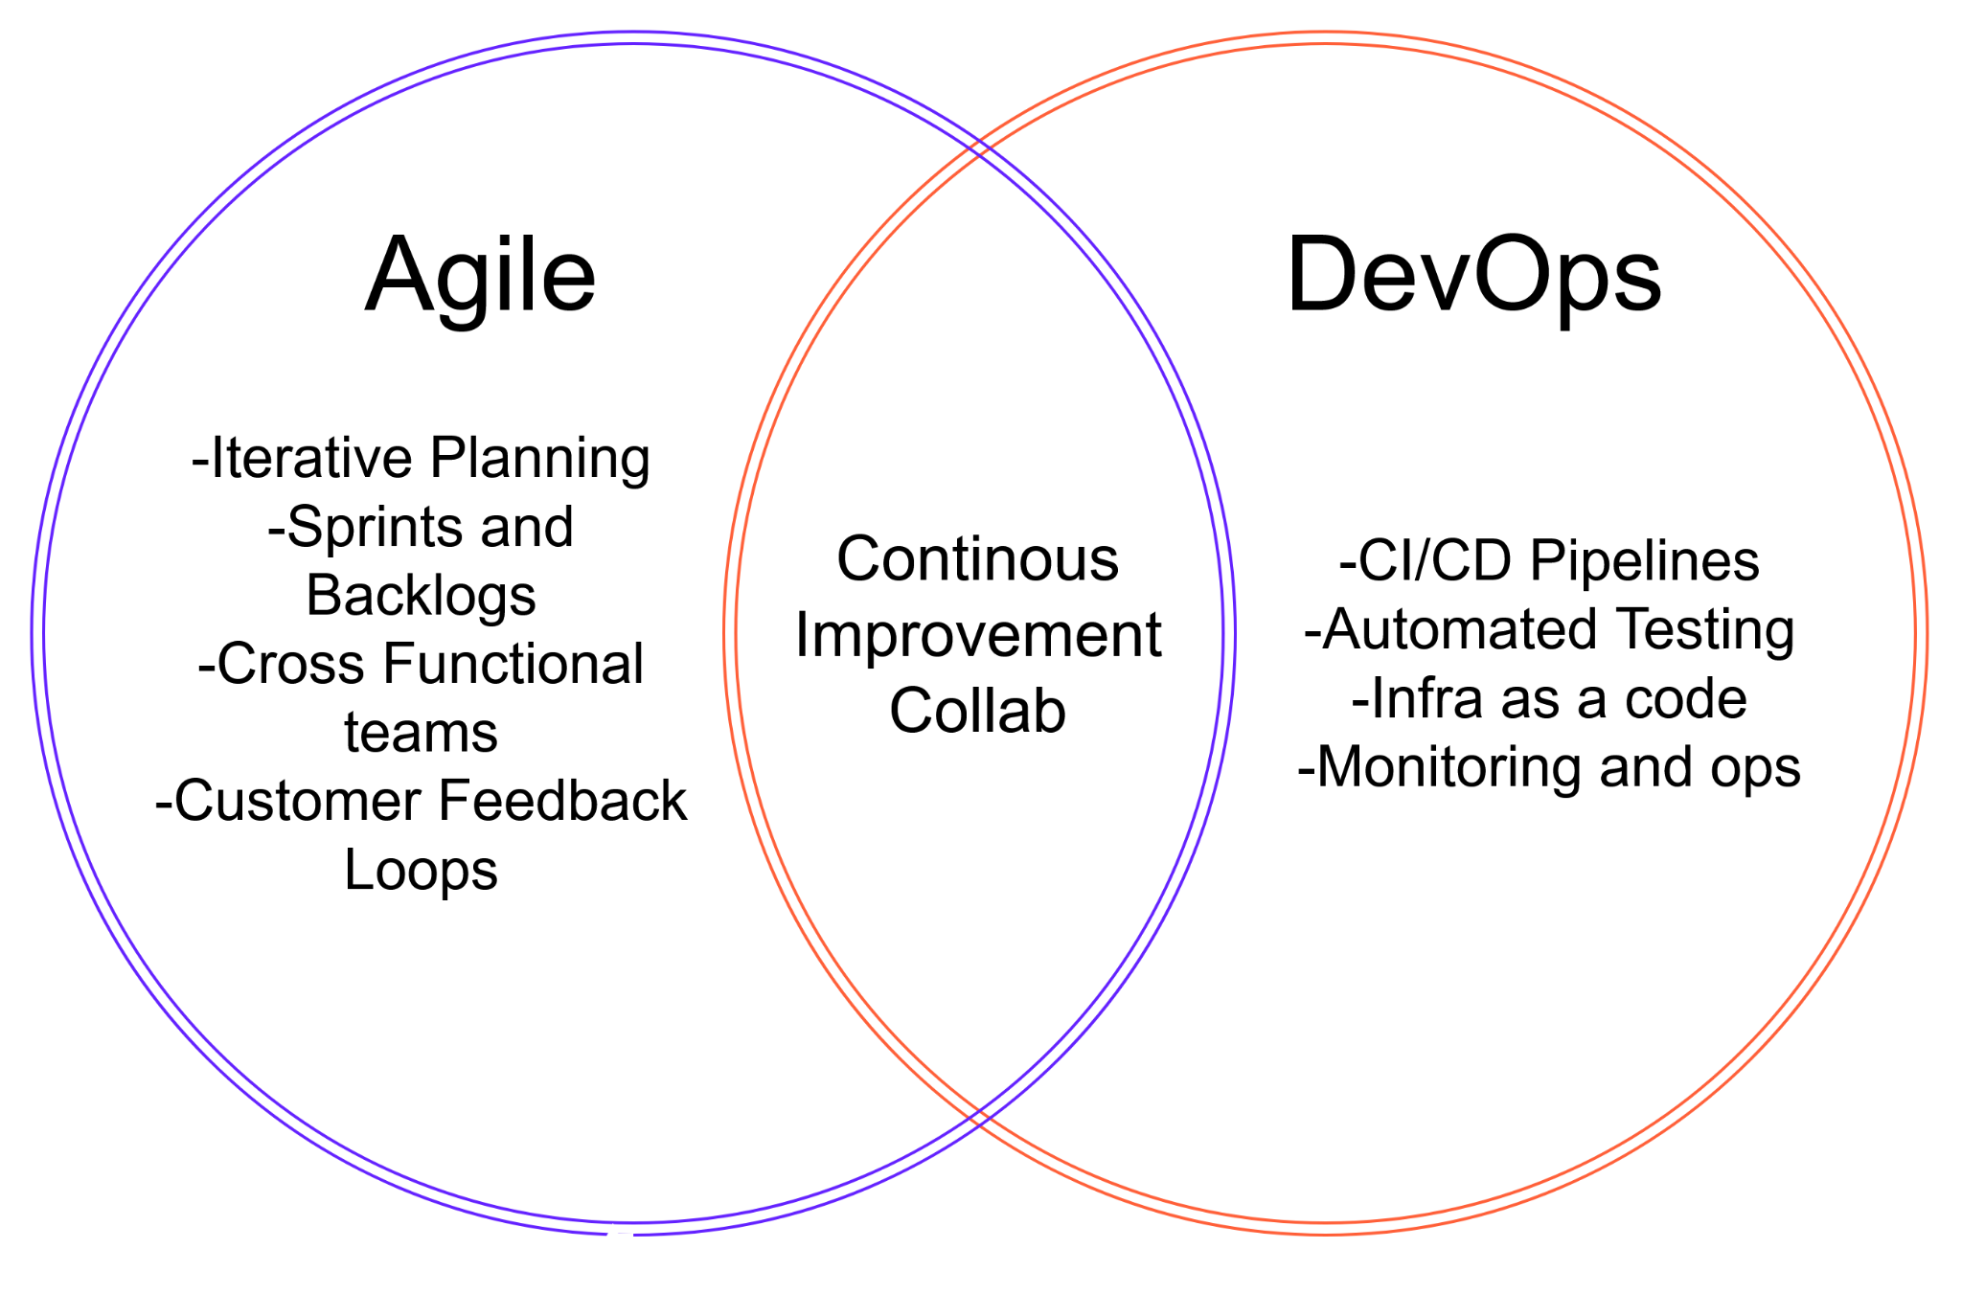
Agile, by contrast, is fundamentally a development methodology that governs how requirements are gathered, prioritized, and built in short, iterative cycles — Scrum, Kanban, and related frameworks. Agile and DevOps share the same ultimate goal, delivering value to customers quickly and reliably, but they answer different questions: Agile asks “Are we building the right thing?” while DevOps asks “Can we run it safely and repeatedly in production?”

1.1. Key Differences:

Dimension | Agile | Devops
Primary Focus | How software is built, planning, iteration, collaboration with customers | How software is delivered, deployed, and operated
Scope of teams | Development and product teams | Development and operations (often QA/security too)
Nature | A methodology / set of frameworks (Scrum, Kanban, XP) | A culture and set of practices (CI/CD, IaC, monitoring)
Feedback source | Primarily the customer / end user | Primarily production monitoring, logs, operational data
Delivery cadence | Iterative delivery in sprints | Continuous delivery / deployment
Core practices | Sprints, backlogs, standups, retrospectives | CI, CD, IaC, microservices, policy as code, monitoring

In practice, Agile and DevOps are complementary rather than competing: Agile shapes how a team plans and builds increments of value, while DevOps ensures those increments can be released to production quickly, safely, and repeatedly. Many organizations run Agile ceremonies for planning work while relying on DevOps tooling and automation — often inside the same platform, such as Jira — to move that work through build, test, and release.

1.2. Core DevOps Practices
Each dimension of DevOps is backed by a specific practice that teams put in place to achieve it:
- Continuous Integration (CI) — developers regularly merge code into a shared repository, and each merge automatically triggers a build and a test run — catching integration problems within minutes instead of weeks.
- Continuous Delivery (CD) — every change that passes CI is automatically built, tested, and kept in a deployment-ready state, so releasing is a low-risk decision rather than a high-stress event.
- Microservices architecture — large systems are broken into small, independently deployable services, so one team can ship a change to their service without waiting on or destabilizing every other team.
- Infrastructure as Code (IaC) — servers, networks, and environments are provisioned through version-controlled code rather than manual configuration, making environments reproducible and eliminating configuration drift.
- Configuration management & Policy as Code — configuration settings and compliance rules are codified and automated, so they can be audited, tested, and rolled back the same way application code can.
- Monitoring and logging — teams capture real-time metrics and logs from running systems, so the impact of every change is visible immediately and incidents can be traced back to their root cause quickly.

1.3. Unpacking the Key Differences
- Primary focus — Agile concerns itself with deciding what to build and iterating on it with stakeholder input; DevOps concerns itself with getting whatever was built into production and keeping it running reliably.
- Scope of teams — Agile typically involves developers and product/business roles (Product Owner, Scrum Master); DevOps widens that circle to include operations, and often QA and security, so releases are a shared responsibility rather than a hand-off.
- Nature — Agile is a defined methodology with named frameworks (Scrum, Kanban, XP) and prescribed ceremonies; DevOps is looser — a culture and a toolchain that different organizations implement in different ways.
- Feedback source — Agile teams adjust course based on what customers say they want; DevOps teams adjust based on what the system is actually doing in production — error rates, latency, uptime.
- Delivery cadence — Agile ships in fixed-length sprints, typically one to four weeks; mature DevOps practice removes that batching entirely, deploying as soon as a change is verified — sometimes many times a day.

Jira vs. Asana , With a Case Study
Jira (Atlassian) and Asana are two of the most widely adopted project and work-management platforms, but they are optimized for different kinds of teams and workflows, which is reflected in how organizations deploy them on real projects. Jira is most often adopted by software development, engineering, IT, and product teams running Agile or DevOps workflows — it provides deep support for Scrum and Kanban boards, backlog and sprint management, issue and bug tracking, and integrations with source-control and CI/CD tools such as Bitbucket and Bamboo. Asana is more commonly used by marketing, creative, operations, and HR teams, or by cross-functional groups coordinating work outside a pure software pipeline, emphasizing an approachable interface and simple task and timeline tracking.

2.1. Feature Comparison
Feature | Jira | Asana
Best suited for | Software development teams | Cross-functional / non-technical teams
Agile support | Native Scrum & Kanban boards, sprints, backlogs | Basic boards and timelines; Agile is a workaround, not native
Learning curve | Steeper — more configuration needed | Simple and intuitive for new users
Integrations | Deep developer tooling (GitHub, Bitbucket, CI/CD) | Broad business tooling (Slack, Google Workspace, Salesforce)
Reporting | Advanced (burndown, velocity, sprint reports) | Lighter (progress views, portfolio dashboards)

2.2. Unpacking the Feature Comparison
- Agile support — Jira's native Scrum and Kanban boards let teams manage backlogs, plan sprints, estimate with story points, and run standard Agile reports (burndown, velocity) without add-ons; Asana can approximate boards and timelines, but sprint mechanics have to be built manually with custom fields and rules, so Agile teams tend to outgrow it.
- Learning curve — Jira rewards the time invested in configuring workflows, permission schemes, and issue types, which is exactly why engineering teams like it — but that same flexibility means new users face a real setup and onboarding cost; Asana is deliberately opinionated and simple, so most users are productive within their first session.
- Integrations — Jira integrates deeply with the developer toolchain — GitHub, Bitbucket, CI/CD pipelines — so a code commit or pull request can automatically update a ticket's status; Asana instead integrates broadly with day-to-day business tools — Slack, Google Workspace, Salesforce — which matters more for teams coordinating people than coordinating code.
- Reporting — Jira's reporting goes deep on engineering-specific metrics — burndown charts, velocity trends, sprint reports — useful for a Scrum Master tuning a team's process; Asana's reporting stays lighter and more visual — progress bars and portfolio dashboards — aimed at giving a non-technical stakeholder a fast read on status.

2.3. Case Study: A Recurring Split-Adoption Pattern
A recurring pattern reported across organizations is a split adoption model. Engineering and product-development groups run their backlog, sprints, and defect tracking in Jira, where fine-grained workflow customization and traceability to code and releases matter most — tickets link directly to commits and pull requests, fitting naturally into a developer's daily workflow inside their IDE and version control system.
Marketing, operations, and other cross-departmental initiatives, meanwhile, are more often coordinated in Asana, where ease of onboarding and visual clarity for non-technical stakeholders matter more than deep engineering tooling — these teams don't need sprint velocity or story points; they need a simple shared timeline and clear task ownership.
The lesson is not that one tool is universally “better,” but that tool choice should follow team structure and workflow: engineering-heavy, Agile/DevOps teams tend to outgrow Asana's simplicity and need Jira's depth, while business and creative teams often find Jira's configuration overhead unnecessary. A product manager tracking a roadmap that spans engineering delivery (Jira) and go-to-market activities (Asana) is a common case where organizations connect the two tools via integrations, so status updates flow between them without requiring every stakeholder to learn both systems.

User Stories and Acceptance Criteria
A User Story is a short, plain-language description of a feature written from the perspective of the end user. It focuses on who wants something, what they want, and why — deliberately leaving out implementation detail so the team can decide the best technical approach. The standard template is:
“As a [type of user], I want [some goal], so that [some reason/benefit].”
Acceptance Criteria (AC) are the specific, testable conditions a User Story must satisfy to be considered “done.” They translate the story's “so that” clause into concrete checks the team and stakeholders can agree on — written from the user's perspective, testable, and agreed upon before development starts rather than invented afterward. A common format for writing acceptance criteria is Given / When / Then:

3.1. The INVEST Checklist
A widely used checklist for judging the quality of a user story is INVEST — the story should be:
- Independent — it can be developed and delivered without being tightly coupled to other stories, so the team can pick it up, build it, and ship it without waiting on unrelated work to finish first.
- Negotiable — its details are a starting point for conversation, not a fixed contract — the story captures the user's intent, while the how gets worked out collaboratively as the team builds it.
- Valuable — it delivers clear value to a user or the business — if a stakeholder can't say why the story matters, it likely needs to be reframed or dropped.
- Estimable — the team can reasonably estimate the effort involved; if a story is too vague or too large to size with any confidence, it usually needs more detail or needs to be split.
- Small — it can be completed within a short iteration — small stories keep progress visible and reduce the risk of a sprint ending with nothing shippable.
- Testable — it includes criteria that let the team confirm it is done — without a testable definition, “done” becomes a matter of opinion rather than fact.

Example
User Story:
As a user, I can sign up using my email and password so that I can access the application.
Acceptance Criteria:
- Only verified email addresses can be used to log in, after the confirmation link has been used.
- The password must be at least six characters long and include both letters and numbers.

Common Pitfalls
- Writing vague stories — a story like “As a user, I can sign up” states no goal and no reason, so the team has nothing to derive acceptance criteria from — without the “so that” clause, testers are left guessing at what “done” actually means.
- Including implementation details — acceptance criteria should describe observable, user-facing behavior, not how the code is built or what testing was run — code-review status and performance-test results belong in the team's separate Definition of Done, which applies to every story rather than being re-litigated story by story.
- Writing oversized stories — a story that can't be finished, estimated, or fully tested inside one iteration is a sign it's bundling multiple pieces of value together; splitting it into smaller, independently valuable stories keeps each one estimable and keeps progress visible sprint over sprint.

Together, the User Story keeps the team focused on user value, while Acceptance Criteria keep everyone like the developers, testers, and the Product Owner ,aligned on exactly what needs to be built and how it will be verified before the story can be marked complete.

Requirements Traceability Matrix (RTM)
A Requirements Traceability Matrix (RTM) is a document or tool used to capture every project requirement and trace it, throughout the project lifecycle, to the design elements, tasks, and test cases that fulfil it. Its central purpose is to confirm that every requirement is covered by at least one test case, so that no functionality is left unverified, and that every deliverable can be traced back to a legitimate business need.

4.1. Types of Traceability
- Forward traceability — maps requirements forward to the test cases that verify them, ensuring the project is progressing toward the intended scope.
- Backward traceability — maps test cases and deliverables back to the originating requirement, helping teams detect and prevent scope creep — functionality that was built but was never actually required.
- Bidirectional traceability — combines both directions, letting the team move from a requirement to its tests and from a test back to its requirement; this is generally considered the most robust form of traceability.

4.2. Typical RTM Structure
Column | Purpose
Requirement ID | A unique identifier so the requirement can be tracked across the entire lifecycle.
Requirement description / category | The statement of the requirement, often classified as functional, non-functional, security, performance, or usability.
Priority and source | How important the requirement is, and which stakeholder or document it originated from.
Design specification link | The design artifact(s) that implement the requirement.
Test case(s) | Unit, integration, system, and user-acceptance test cases that verify the requirement.
Status | Current state — e.g. in progress, implemented, tested, passed, failed.

An RTM gives project managers, QA teams, and auditors full visibility into which requirements are covered, which are still outstanding, and which areas generate the most defects — insight that would be difficult to reconstruct after the fact. It is especially valuable in regulated industries and in projects that must demonstrate, for compliance or contractual reasons, that every stated requirement was actually delivered and verified. As projects grow in scale or regulatory burden, spreadsheet-based RTMs are often replaced by dedicated requirements-management tools such as IBM DOORS, which automate traceability across design, code, and test artifacts.

Tools for Requirement Management

Requirement management tools are software applications used to capture, organize, track, and manage software requirements throughout the development lifecycle. They help ensure that requirements are clearly documented, traceable, and properly communicated among stakeholders.

Examples:

IBM DOORS (Dynamic Object-Oriented Requirements System): A widely used tool for managing and tracing requirements. It allows teams to create requirements, maintain relationships between them, track changes, and establish traceability between requirements, design, development, and testing.

Jira: Primarily a project and issue-tracking tool, but it can also be used to manage requirements through user stories, tasks, and workflows.

Azure DevOps: Supports requirements through work items, user stories, backlogs, and links between requirements, code, and test cases.

Key features of requirement management tools:

Requirement documentation – Store and organize requirements in a structured manner.

Traceability – Link requirements to design, code, and test cases.

Version control – Track changes made to requirements over time.

Change management – Manage and assess the impact of requirement changes.

Collaboration – Allow different stakeholders to review and discuss requirements.

Reporting – Generate reports on requirement status, coverage, and progress.

Conclusion
Successful software development involves much more than simply writing code. It requires clearly written user stories supported by measurable acceptance criteria, and proper traceability that links each requirement to its corresponding verification. Agile provides an effective approach for planning and developing the software, while DevOps focuses on its delivery, deployment, and ongoing operation. These practices are further strengthened by appropriate tools and platforms: Jira and Asana demonstrate that the choice of a project management tool should depend on the type and requirements of the work, while a Requirements Traceability Matrix — and specialized platforms such as IBM DOORS for large-scale or regulated projects — ensures that no requirement goes unverified. Collectively, these practices and tools establish a structured process that connects a stakeholder's initial requirement to a verified, delivered, and maintainable software solution.

